**1. Why we use Vector DB ?**

We can provide a smaller document to LLM based on Vecotr DB’ semantic search, reduce context window limit to reduce cost incurred by LLM call.Inference time will improve as well.

**2. Provide the high level design ?**

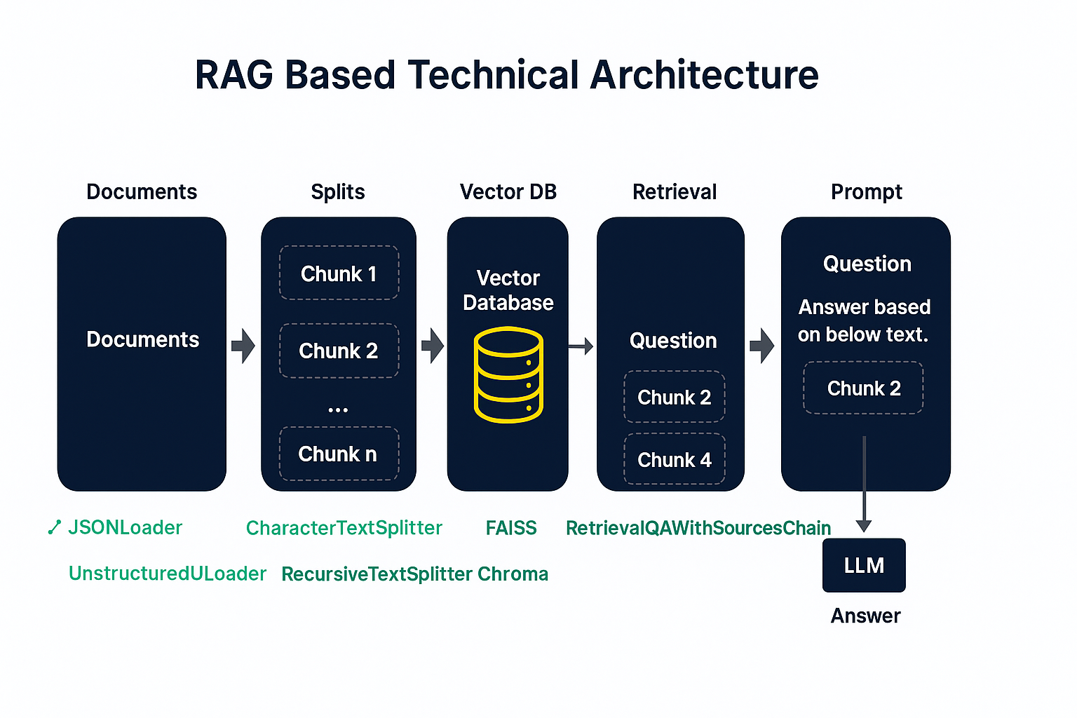

**3. What would be design of semantic router?**

We can use Python’s semantic router . It means based on question chatbot can find the intent and module which can handle user query e.g. FAQ , Product inquiry.If for example its FAQ we can use ChromDB for RAG solution and for product inquiry we can use Database e.g. user’s query can be mapped to sql query using LLM and result extracted from Database.

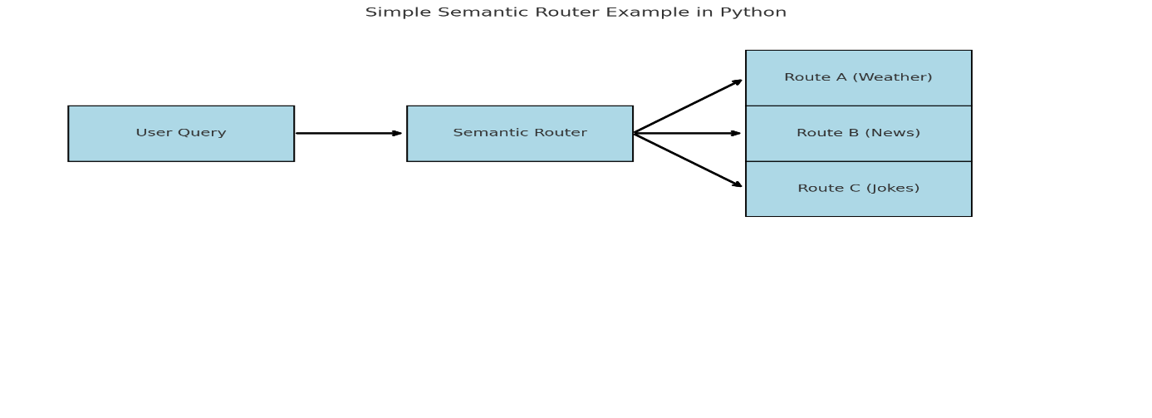

**4. What is the difference between SQL and NoSQL databases?**

SQL databases are relational and use structured query language, while NoSQL databases are non-relational and are used for unstructured or semi-structured data.

**5. What is cloud computing?**

Cloud computing is the delivery of computing services—including servers, storage, databases, networking, software—over the internet ('the cloud') to offer faster innovation and flexible resources.